Chapter test with answers

Section A Multiple choice (15 marks)
1 Which subatomic particle contributes mass but no charge to the atom?
A Proton
B Neutron
C Electron
D Nucleon
2 The atomic number of zinc is:
A 65.
B 30.
C 91.
D 40.

For questions 4–6 refer to the table below, which shows the electron configuration of six atoms, labelled I–VI.
Atom | I | II | III | IV | V | VI
Electron configuration | 2, 1 | 2, 8, 7 | 2, 8, 8, 2 | 2, 8 | 2, 3 | 2, 8, 1
3 Which atom/s are from the same period of the periodic table?
A I, II, III
B I and IV
C II, III, VI
D I, IV, V
4 Which atom is an inert gas?
A I
B II
C III
D IV
5 Which atom has five protons?
A I
B III
C V
D VI

6 The diagram below shows an atom of beryllium. What is the name of the structure labelled X?
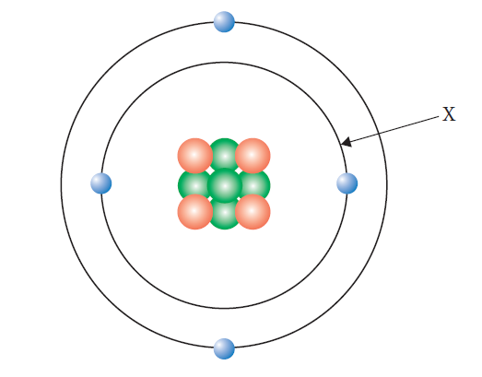
A Valence electron
B Nucleus
C Electron shell
D Electron

7 Why is the relative atomic mass on the periodic table a decimal?
A It is the average of the abundance and mass of all of the isotopes of the element.
B It is the average of the abundance and mass of all of the allotropes of the element.
C It depends on the percentage abundance of the element in the Earth’s crust.
D It depends on which atom of carbon the element is being compared to.
8 The order of subshells in terms of their energy is:
A 1s<2s<3s<4s<2p<3p<4p.
B 1s<2s<2p<3s<3p<3d<4s<4p.
C 1s<2s<2p<3s<3p<4s<3d<4p.
D 1s<2s<3s<3p<4s<4p.
9 Which of these elements has the largest atomic radius?
A Potassium
B Calcium
C Bromine
D Krypton

10 Which of these elements has the lowest ionisation energy?
A Fluorine
B Chlorine
C Bromine
D Iodine
11 Which of the following elements react with water in similar ways?
A Na and Al
B Na and K
C Mg and P
D Li and Br

12 If two electrons were removed from a neutral atom with the electron configuration 2, 8, 2 the new species would then have the same number of protons as:
A Ne.
B Mg.
C F.
D Na.
13 Which of the following is a semi-metal?
A Be
B B
C P
D Mg
14 Which of the following describes why water droplets appear on a cold bathroom mirror when you are having a hot shower?
A Evaporating
B Boiling
C Melting
D Condensing
15 In which of the following separation techniques is the term residue used?
A Evaporation
B Decanting
C Sieving
D Filtration

16 Immiscible liquids are generally separated in the science laboratory using:
A a filter funnel.
B a separating funnel.
C a condenser.
D a Bunsen burner and evaporating basin.
17 What does the term filtrate refer to?
A Smaller solid particles that pass through a sieve
B Solid particles that are too large to pass through filter paper
C The liquid or solution that passes through the filter paper
D The liquid or solution that remains after evaporating
18 Evaporation is used as a separation technique when:
A only the solute is to be kept.
B only the solvent is to be kept.
C solid particles can be seen in the mixture.
D both the solute and the solvent are to be kept.
19 Which of the following is not a mixture?
A Tap water
B Carbon dioxide gas
C Coffee
D Air
20 When a liquid is cooled enough, it will turn into a solid. The temperature at which this occurs is known as the:
A boiling point.
B melting point.
C state.
D thermal conductivity.

21 Mixtures that contain solids with different particle sizes are not usually separated by:
A sieving.
B vaporisation.
C filtration.
D straining.

22 During distillation, the thermometer is used to:
A work out when the substance with the highest boiling point has changed into a gas.
B control the temperature of the liquid or solution being heated in the round-bottom flask.
C determine the temperature of the vapour entering the condenser.
D ensure the experiment remains safe at all times when carried out in the laboratory.

23 Which of the following is always a mixture?
A An element
B A compound
C A liquid
D A solution

24 Which of the following is false?
A Mixtures can be solids, liquids or gases.
B Mixtures can be homogeneous or heterogeneous.
C Mixtures contain at least two different types of particle physically combined.
D Mixtures always have variable composition.

Section B Short answer
1 Oxygen has three isotopes, oxygen-16, oxygen-17 and oxygen-18. Their relative abundances are 99.76%, 0.04% and 0.20%, respectively.
a Define the term isotope. (1 mark)
Answer: Isotopes are different forms of the same element, with the same number of protons and electrons but differing numbers of neutrons.
b Calculate the relative atomic mass of oxygen. (2 marks)
Answer: (99.76 × 16) + (0.04 × 17) + (0.20 × 18) ÷ 100
= 16.0044 = 16.00
2 Complete the following table.
Element | Atomic number | Mass number | Number of protons | Number of neutrons | Number of electrons
beryllium | 4 | 9 | 4 | 5 | 4
selenium | 34 | 79 | 34 | 45 | 34
(3 marks)
3 Explain why ionisation energy and atomic radius show opposite trends for the first 20 elements. (3 marks)
Answer: First ionisation energy decreases down a group and increases across a period. Atomic radius increases down a group and decreases across a period. (1 mark)
As you move down a group the number of full electron shells between the nucleus and the valence shell increases. This increases the atomic radius, and decreases the energy required to remove an electron from the valence shell (electrons are shielded from the nucleus and so are easier to remove). Hence, the two trends down a group are opposite. (1 mark)
As you move across a period the number of protons in the nucleus increases. Electrons are being added to the same valence shell, so they still have the same degree of shielding from the charge in the nucleus. Thus the valence electrons are held more tightly and so atomic radius decreases, but as the electrons are harder to remove, first ionisation energy increases. (1 mark)

4 The properties of three elements, X, Y and Z, are shown below.
Element/property | Boiling point | Melting point | Electrical conductivity (solid)
X | –152 | –157 | n/a
Y | 609 | 419 | high
Z | 892 | 98 | high
a Compare the state at room temperature for elements X and Y. (2 marks)
Answer: X is a gas, as the melting and boiling points are below room temperature. (1 mark)
Y is a solid, as the melting and boiling points are above room temperature. (1 mark)
b Describe where element Z would be found on the periodic table. Give a reason for your answer. (1 mark)
Answer: Z is a solid at room temperature and has high electrical conductivity. Thus it is a metal and would be found on the left-hand side of the periodic table or in with the transition metals.
5 Complete the following table.
Answer:
Separation method | Property used in the separation (with both components to be retained)
Separating funnel | The components are liquids with different densities
Filtration | The components are substances with different particle sizes
Distillation | The components are substances with different boiling points
(3 marks)
6 A student was given a mixture of sodium chloride (common table salt), small cork pieces, dirt and iron filings. Draw a flow chart to show the procedure the student should follow, if all components are required to be kept. Be sure to show what is removed at each step. (3 marks)
Answer: (Some students may do this differently.)
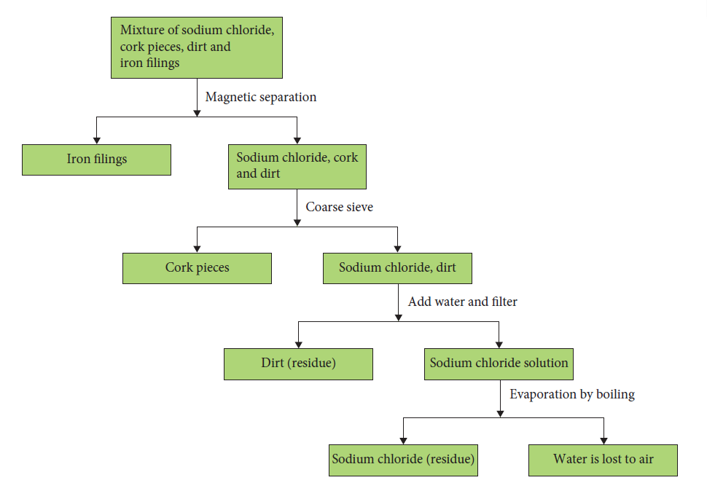

7 The table below compares some properties of two substances, I and II. Decide whether each substance is an element, compound or mixture. Give reasons for your answers. (3 marks)
Substance | Melting point | Separation/decomposition
I | No definite melting point | Components can be separated by physical means
II | > 900°C | Cannot be decomposed into simpler substances
Answer: Substance I is a mixture: mixtures are made up of different types of substances in differing amounts. (1 mark)
Hence the melting points are varied and the different components can be separated by physical means, such as filtration. (1 mark)
Substance II is an element, as it cannot be decomposed into a simpler substance. (1 mark)
8 Draw particle diagrams of specific examples of substances to illustrate the difference between a pure substance and a mixture. (3 marks)
Answer: Carbon dioxide gas is a pure substance. This is shown in the diagram below, as there is only one type of particle in the container. (1 mark)
Air is a mixture made up of a number of different gases, such as carbon dioxide, nitrogen gas and oxygen gas. This is shown below as there are four different types of particle in the container, physically combined. (1 mark)
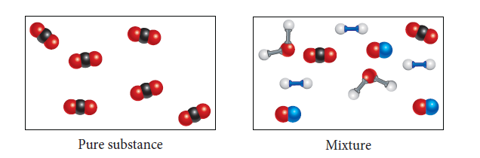 (1 mark)

9 Using correct scientific terminology, clearly explain how the process of distillation can be used to separate a mixture of water and ethanol (BP = 78°C). (3 marks)
Answer: The water and ethanol mixture is placed in the round-bottomed flask and heated to approximately 78°C using a water bath and hot plate. At this temperature, ethanol changes into a gas (evaporates) and rises from the surface. (1 mark)
The ethanol vapour enters the condenser tube, which has cool water running around the outside in the ‘water jacket’. This cools down the gas and condenses it back into a liquid, and it runs into a beaker as the distillate. (1 mark)
It is important not to let the temperature of the mixture reach 100°C or the water will also evaporate and be collected. The water stays in the round-bottomed flask. (1 mark)

